## Controller – LPE

### General Overview

This module, which is abbreviated to dla_crtl_lpe, computes address of global buffer needed by LPE and generates corresponding control signals according to the related registers and some control signals to decide the behaviors of LPE

### I/O Definition

**Table 1**

|  |  |  |  |
| --- | --- | --- | --- |
| **Signals** | **Direction** | **Bit Width** | **Description** |
| **Global Signals** | | | |
| clk | input | 1 |  |
| rst | input | 1 |  |
| **Instruction Signals** | | | |
| start_lpe | input | 1 | Operation start signal of LPE |
| stgr_lpe_src_addr | input | 1 | Start address of the source data |
| stgr_lpe_src_len | input | 13 | The length of the source data rectangle |
| stgr_lpe_src_skip | input | 13 | The address gap between two source data rows |
| stgr_lpe_src_iter | input | 13 | The number of rows of the source data rectangle |
| stgr_lpe_dest_addr | input | 13 | Start address of the destination data |
| stgr_lpe_dest_len | input | 13 | The length of the destination data rectangle |
| stgr_lpe_dest_skip | input | 13 | The address gap between two destination data rows |
| stgr_lpe_dest_iter | input | 13 | The number of rows of the destination data rectangle |
| stgr_lpe_overlay | input | 7 | Indicates the number of slices of a kernel |
| stgr_lpe_relu | input | 1 | Directly connected to “ctrl_lpe_relu” |
| stgr_lpe_acc_bypass | input | 1 | Directly connected to “ctrl_lpe_acc_bypass” |
| ctrl_adt_fifo_set | input | 1 | Enable signal of writing data to the fifo behind the adder tree in LPE |
| stgr_lpe_sprmps | input | 2 | Directly connected to “ctrl_lpe_sprmps” |
| **Ctrl Signals** | | | |
| ctrl_lpe_gb_addr | output | 13 | The address of global buffer that LPE needs to read from or write to |
| ctrl_lpe_gb_ren | output | 1 | read enable signal for LPE when  it needs to read data from global buffer. The corresponding address signal has a delay of one clock cycle |
| ctrl_lpe_gb_wen | output | 1 | write enable signal for LPE when it needs to write data to global buffer. The corresponding address signal has a delay of one clock cycle |
| ctrl_adt_fifo_ren | output | 1 | Enable signal for LPE to read data from the fifo behind the adder tree |
| ctrl_lpe_relu | output | 1 | Enable relu function of LPE |
| ctrl_lpe_acc_bypass | output | 1 | Bypass the accumulater behind the adder tree in LPE |
| ctrl_lpe_sprmps | output | 2 | Indicates the work modes of LPE, there are three modes: “image”, “none” and “all” |
| complete_lpe | output | 1 | Indicates the complete of current operation of LPE |

### Description

This module is mainly made up by four blocks: b_ctrl_lpe_raddr, b_crtl_lpe_waddr, b_ctrl_lpe_fsm and b_ctrl_lpe_complete. The function of b_ctrl_lpe_raddr is to compute the correct address of global buffer when the LPE needs to read data from and the function of b_ctrl_lpe_waddr is to compute the correct address of global buffer when the LPE needs to write data to global buffer. Block b_ctrl_lpe_fsm is a finite state machine, which is used to control the work state of LPE. Finally, the function of b_ctrl_lpe_complete is to decide the value of complete_lpe which indicates whether LPE completes current operation. The details of these blocks will be illustrated below.

#### b_ctrl_lpe_raddr and b_ctrl_lpe_waddr

The architectures of b_ctrl_lpe_raddr and b_ctrl_lpe_waddr are same. Use b_ctrl_lpe_raddr for an example, this block uses two registers named gb_raddr and gb_rleap(when LPE needs to write multiple results to global buffer, gb_rleap stores the offsets between two continuous results) to store parts of the final address, which equal to the sum of gb_raddr and gb_rleap. The block use several counters to decide the values of gb_raddr and gb_rleap in different situations. Picture below show the diagram of b_ctrl_lpe_raddr.



Figure 1. Diagram of b_ctrl_lpe_raddr

Depends on the ctrl_lpe_gb_ren signal, only one address(generated by b_ctrl_lpe_raddr or b_ctrl_lpe_waddr) can be passed to the LPE as ctrl_lpe_gb_addr.

#### b_ctrl_lpe_fsm

Sometimes, the results of adder tree need to do addition with the number read from the corresponding global buffer before write back to the global buffer. But sometimes the results of adder tree can directly write back to the global buffer. The pipelines of two data-paths are different, so the controller use a fsm to help generate correct control signals at the right time according to whether the addition is needed. Picture below illustrates the state transitions of this fsm.



Figure 2. Diagram of b_ctrl_lpe_fsm

The time sequences of some control signals depend on the value of stgr_lpe_acc_bypass, Figure 3 and Figure 4 show the difference.

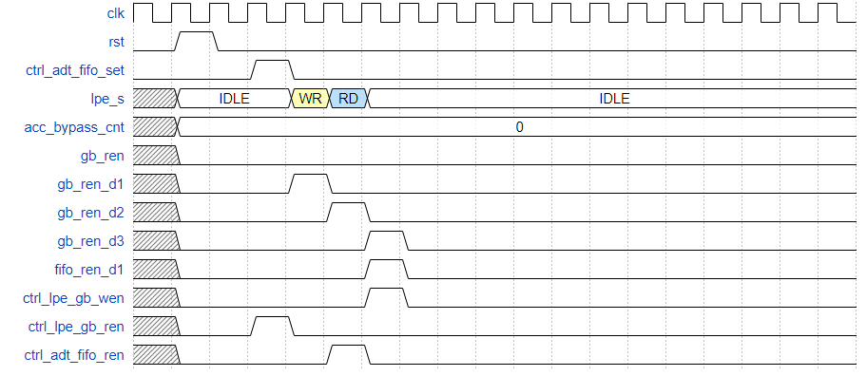

Figure 3. ACC_BYPASS(cnt_leap_max = 0)



Figure 4. ACC NOT BYPASS(cnt_leap_max = 3)

#### b_ctrl_lpe_complete

This block uses write enable signal of global buffer and values of several counters to judge if LPE complete current operation then outputs complete_lpe signal. The logic of this block is below.



Figure 5. Diagram of b_ctrl_lpe_complete

#### Other Logic

If the kernel of a convolution operation is large, the kernel will be divided into several slices. Ane the LPE handles the results caused by slices of the same kernel with the same read address and write address. In the controller for LPE, two counters(cnt_src_overlay and cnt_dest_overlay) are used to indicate whether all slices are handled. The logic of the counter is below(counters for read address generation and write address generation are same).



Figure 6. The Logic of cnt_src_overlay